

**Task Force on Climate-related Financial Disclosures (“TCFD”) Report**

[Client’s Name]

[Date]

# Table of Contents

Table of Contents 2

List of Tables and Figures 4

Abbreviations 5

1. A Message from the Group Chief Executive Officer 6

2. Executive Summary 7

3. Introduction 8

3.1 About the Task Force on Climate-related Financial Disclosures (TCFD) 8

3.2 TCFD Index 9

3.3 Our Climate Action 10

4. Governance 11

4.1 Governance Structure for Climate-related Initiatives 11

4.2 Board Oversight 13

4.3 Management Responsibility 13

4.4 Keeping Up with the Climate Agenda 14

4.5 Stakeholder engagement 15

5. Strategy 16

5.1 Our Climate Goals 16

5.2 Identification and Impact of Climate-related Risks 16

5.1 Climate-related Opportunities 17

5.2 Our Transition Plan Towards Net-Zero 18

5.3 Scenario Analysis 25

6. Risk Management 31

6.1 Processes for Managing Climate-related Risks. 31

6.2 Risk Identification 33

6.3 Risk Management Processes 35

6.4 Risk Assessment and Measurement 35

7. Metrics and Targets 39

7.1 An Overview of Metrics 39

7.2 Progress against Committed Targets 47

8. Conclusion and Looking Ahead 48

9. Appendix 49

9.1 Appendix 1: 49

9.2 Appendix 2: 49

# List of Tables and Figures

Tables

Table 1: Terms of Abbreviation 4

Figures

**No table of figures entries found.**

# Abbreviations

Table 1: Terms of Abbreviation

| **Abbreviation** | **Description** |
| --- | --- |
|  |  |
|  |  |
|  |  |
|  |  |
|  |  |
|  |  |
|  |  |
|  |  |
|  |  |

# A Message from the Group Chief Executive Officer

[Grab your reader’s attention with a great quote from the document or use this space to emphasize a key point. To place this text box anywhere on the page, just drag it.]

[Grab your reader’s attention with a great quote from the document or use this space to emphasize a key point. To place this text box anywhere on the page, just drag it.]

**Image of Group CEO**

# Executive Summary

# Introduction

## About the Task Force on Climate-related Financial Disclosures (TCFD)

The Task Force on Climate-related Financial Disclosures (TCFD) was established by the Financial Stability Board (FSB) to develop a set of voluntary, consistent climate-related financial risk disclosures for use by companies, banks, and investors. This initiative arose from the recognition that climate change poses significant risks to the global financial system, necessitating standardized reporting to enhance the understanding and management of these risks. The TCFD aims to improve the reporting of climate-related financial information, promoting more informed investment, credit, and insurance underwriting decisions. Enhanced transparency through TCFD disclosures enables stakeholders to better understand the concentrations of carbon-related assets in the financial sector and the financial system's exposures to climate-related risks. By providing a framework for consistent and comparable disclosures, the TCFD helps organizations identify and communicate the financial implications of climate change, thus supporting the transition to a sustainable, low-carbon economy.

**Figure 1. Core Elements of the Task Force on Climate Related Disclosures**

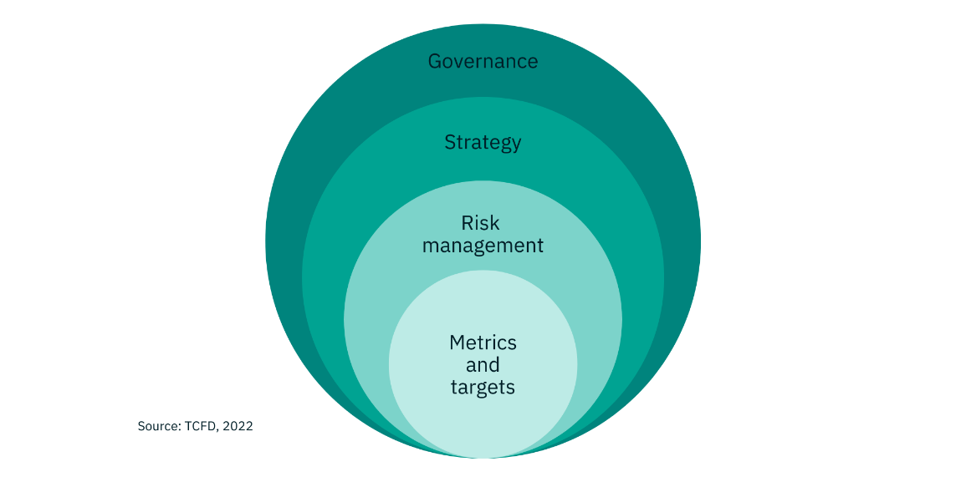

**Governance**

The organization’s governance around climate-related risks and opportunities

**Strategy**

The actual and potential impacts of climate-related risks and opportunities on the organization’s businesses, strategy, and financial planning

**Risk Management**

The processes used by the organization to identify, assess and manage climate-related risks

**Metrics and Targets**

The metrics and targets used to assess and manage relevant climate-related risks and opportunities

*Source: TCFD, 2022*

The recommendations are structured around four thematic areas that represent core elements of how organizations operate (Figure 1). Adopting the TCFD recommendations offers organizations several benefits, including enhanced transparency and accountability through clear and consistent disclosures, improved risk management by integrating climate-related risks into the overall risk framework, and more informed decision-making, which supports stable and resilient financial systems. Additionally, proactive management and disclosure of climate-related risks and opportunities can provide a competitive advantage by demonstrating sustainability leadership and attracting investment from environmentally conscious stakeholders.

## TCFD Index

**Table 1. Overview of the Recommendations for each Core Element**

|  |  |  |
| --- | --- | --- |
| **Section** | **Recommendation** | **Page reference** |
| **Governance** | 1. Description on the Board’s oversight of climate-related risks and opportunities |  |
| 1. Description of management’s role in assessing and managing climate-related risks and opportunities |  |
| **Strategy** | 1. Description of climate-related risks and opportunities the organisation has identified over the short, medium, and long term |  |
| 1. Description of the impact of climate-related risks and opportunities on the organisation’s business, strategy, and financial planning |  |
| 1. Description of the resilience of the organisation’s strategy, taking into consideration different climate-related scenarios, including a 2°C or lower scenario |  |
| **Risk Management** | 1. Description of the organisations processes for identifying and assessing climate-related risks |  |
| 1. Description of the organisations processes for managing climate-related risks |  |
| 1. Description of how the processes for identifying, assessing, managing climate-related risks are integrated into the organisation’s overall risk management |  |
| **Metrics and Targets** | 1. Disclosure of metrics used by the organisation to assess climate-related risks and opportunities in line with its strategy and risk management processes |  |
| 1. Disclosure of Scope 1, Scope 2, and, if appropriate, Scope 3 greenhouse gas (GHG) emissions and its related risks |  |
| 1. Description of the targets used by the organisation to manage climate-related risks and opportunities and performance against targets |  |

* **October 2023**

2023 Status Report

* **October 2023**

The Task Force’s Last Status Report

* **2020–2021**

Consultations on Metrics, Targets, and Transition Plans

* **October 2021**

2021 Status Report

* **October 2021**

Guidance on Metrics, Targets, and Transition Plans and Updated Implementation Guidance

* **February 2022**

TCFD Workshop Presentation Series

* **February and March 2022**

Surveys on Reporting Trends and Challenges

* **2018–2019**

TCFD Implementation and Use Survey

* **June 2019**

2019 Status Report

## Our Climate Action

**Figure 4. History of [Client’s Name] Climate initiatives**

[Grab your reader’s attention with a great quote from the document or use this space to emphasize a key point. To place this text box anywhere on the page, just drag it.]

[Grab your reader’s attention with a great quote from the document or use this space to emphasize a key point. To place this text box anywhere on the page, just drag it.]

[Grab your reader’s attention with a great quote from the document or use this space to emphasize a key point. To place this text box anywhere on the page, just drag it.]

[Grab your reader’s attention with a great quote from the document or use this space to emphasize a key point. To place this text box anywhere on the page, just drag it.]

[Grab your reader’s attention with a great quote from the document or use this space to emphasize a key point. To place this text box anywhere on the page, just drag it.]

[Grab your reader’s attention with a great quote from the document or use this space to emphasize a key point. To place this text box anywhere on the page, just drag it.]

[Grab your reader’s attention with a great quote from the document or use this space to emphasize a key point. To place this text box anywhere on the page, just drag it.]

# Governance

[Client’s name] recognises the complexities of climate change and the importance of exemplary business practices for sustained organizational growth. In [Year], following [event that initiated client’s climate activities], [Client’s Name] has been committed to fostering ethical conduct and strong governance throughout our operations. Our unwavering dedication to sustainable development is reflected through the establishment of the [Client’s Sustainability committee]; formed as a part of [Client’s Sustainability Framework], which guides our organisation by integrating climate-related considerations into our business standards, and conduct. Following the [Client’s Sustainability Framework], we have developed a robust corporate governance framework to ensure effective leadership and oversight of global climate issues to achieve our [Client’s Net-zero targets]. When developing our governance strategy to oversee climate-related matters within [Client’s name] we employ a top-down methodology to integrate sustainability from the highest governing body, [the Board], down to the operational level.

## Governance Structure for Climate-related Initiatives

The Board of Directors sets the strategic direction and overall risk management for the organization and oversees social and environmental matters, including climate-related risks. In [Year], the Board received regular updates on [climate-related issues, policies and reports identified by the client] from the [Title of Responsible Executive]. These updates covered [key government and regulatory policies, regulatory engagement, and ESG matters, including climate issues]. Additionally, climate-specific updates were provided to the board [frequency (i.e., monthly)] by the [Title of Responsible Executive] and [Title of Sustainability Head], focusing on climate strategy, policy updates, industry trends, stakeholder engagement, and target-setting.

[Client’s Name] ensures climate-related initiatives are thoroughly discussed at the business execution level, including forums such as the [Sustainability Promotion Committee], [Risk Management Committee], and [Executive Management Committee]. These committees evaluate and deliberate on climate strategies and policies, reporting outcomes to the Board of Directors and the Risk Committee, which supervises implementation.

The [Title of Responsible Executive] regularly engages with the [Group Chief Executive, Chairman, and Non-Executive Directors] on the Group’s climate strategy, facilitating informed decision-making. This proactive engagement helps [Client’s Name] adapt to evolving regulatory landscapes, market demands, and stakeholder expectations, reinforcing its commitment to managing climate-related risks and opportunities effectively.

**Figure 5. Overview of [Client’s Name] Governance Structure**

**Group Chief Executive Officer (CEO)** Accountable to the Board for the implementation of [Client’s Name]’s climate change strategy

**Board of Directors** Oversees all environmental and social sustainability-related matters, including climate risks and opportunities, and engages with management on climate-related activities, including [Client’s Name] Net Zero Goals and Strategy

**Board-Level Committees**

**Board Audit Committee**

Assesses the integrity of [Client’s Name]’s financial statements and evaluates the effectiveness of [Client’s Name]’s internal controls.

**Board Risk Committee**

Reviews and monitors [Client’s Name]’s approach to managing the financial and operational risks including those associated with climate change.

**Group Chief Risk Officer (CRO)**

Responsible for monitoring the status of [Client’s Name]’s initiatives addressing climate-related financial risk.

**Group Chief Sustainability Officer (CSO)**

Responsible for overseeing [Client’s Name] sustainability initiatives and effectively integrating sustainability into [Client’s Name]’s operations.

**Group Risk Committee**

Supports the CRO in overseeing the identification and integration of climate related risks into [Client’s Name]’s overall risk management framework.

**Group Responsible Growth Committee (RGC)**

Supports the CSO in overseeing the implementation of the Group’s sustainability initiatives, ensuring ESG factors are integrated into [Client’s Name]’s strategy, policy, and operations.

**Management-Level Committees**

Accountable for the execution of the climate strategy, including climate risk management

## Board Oversight

The Board of Directors at [Client’s Name], plays a critical role in overseeing climate-related risks and opportunities. The Board is actively involved in setting strategic direction, approving policies, and monitoring the implementation of initiatives that address climate change. By integrating climate considerations into our governance framework, the Board ensures that climate-related risks are effectively managed and that opportunities for sustainable growth are maximized, aligning with our commitment to environmental stewardship and long-term value creation.

**Table 2. Overview of the Board’s Oversight over [Client’s Name]**

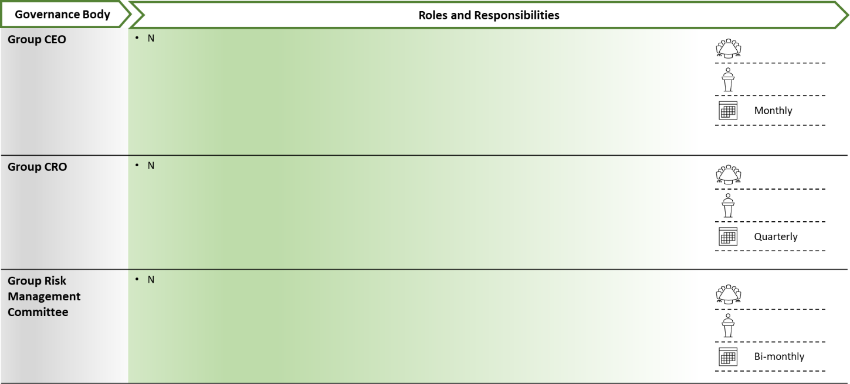

## Management Responsibility

At [Client’s Name], our management team is dedicated to assessing and managing climate-related risks and opportunities. The executive leadership integrates climate considerations into our overall risk management framework and business strategy. Through regular risk assessments conducted [frequency (i.e., monthly)], scenario analyses, and the development of sustainable practices, management ensures that our operations align with international climate commitments. This proactive approach enables us to mitigate potential risks, seize emerging opportunities, and drive sustainable growth while fulfilling our environmental responsibilities.

**Table 3. Overview of Management’s Oversight over [Client’s Name]’s Climate-related Processes**

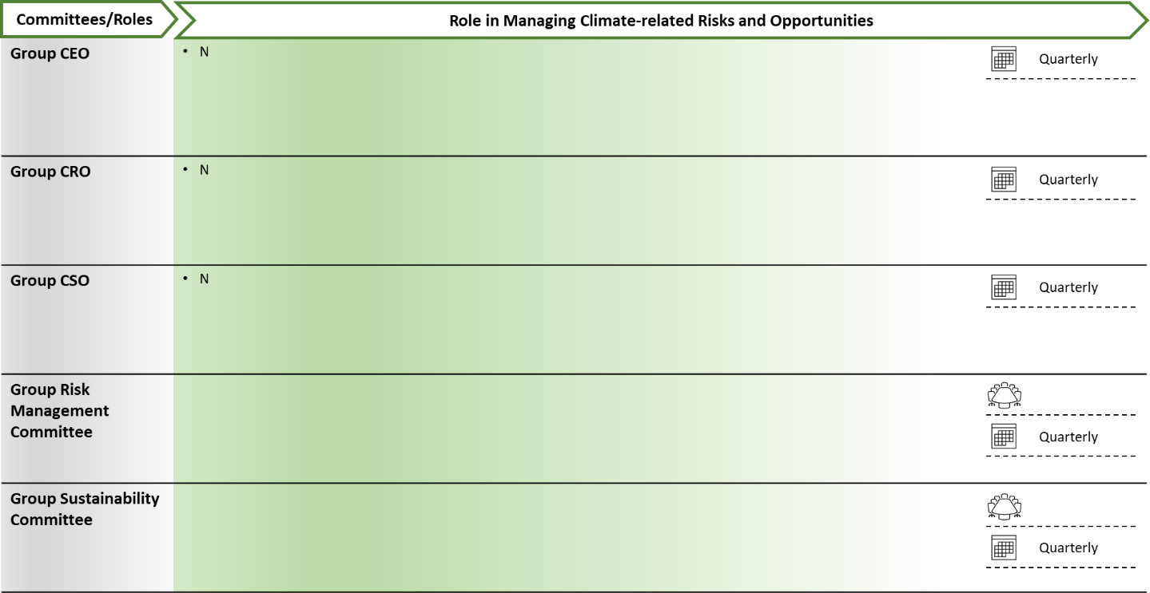

## Keeping Up with the Climate Agenda

In keeping with our commitment to [local or international regulation/agendas (i.e., Paris Agreement, NZBA, or CRMSA)] [Client’s Name] has established a robust climate agenda detailing the policies and processes used to ensure the continuous monitoring and management of climate-related issues, providing comprehensive insights for informed decision-making to key stakeholders. One key component of the climate agenda includes [(quarterly) reports generated by the Climate Risk Management Team/Sustainability Committee and presented to the [Executive Management Committee/Board of Directors]. These reports cover climate risks and opportunities, policy changes, regulatory developments, and progress towards climate goals, including detailed analyses of greenhouse gas emissions, energy consumption, and other environmental indicators.

Furthermore, bi-annual scenario analyses and stress tests assess the impacts of various climate scenarios on operations and financial performance. Findings from these analyses are discussed in strategic planning sessions to inform long-term business strategies. We also conduct annual workshops and training sessions for executives to keep our leadership updated on climate science, regulatory expectations, and industry best practices, encouraging cross-functional collaboration and continuous improvement.

To ensure transparency and accountability, we regularly track and report key performance indicators (KPIs) measuring carbon footprint reduction, energy efficiency improvements, and progress towards sustainability goals. By integrating these mechanisms, [Client’s Name] proactively manages climate-related risks and opportunities, safeguarding operations and contributing to environmental sustainability, reinforcing our position as a responsible and forward-thinking organization.

## Stakeholder engagement

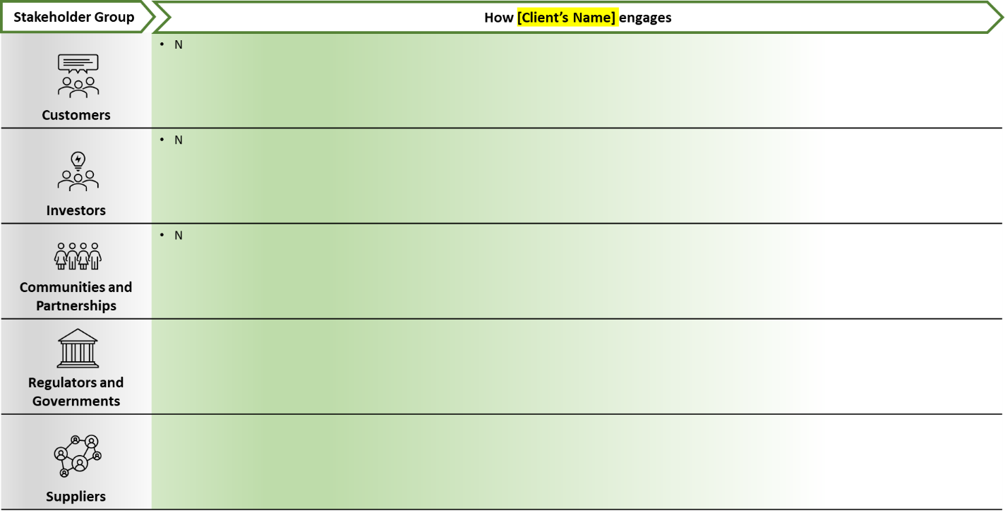

# Strategy

In the strategy section of the [Title of Client’s Report], the report will aim to provide a greater insight to stakeholders and investors regarding how climate-related risks and opportunities impacts [Client’s name] business, strategy, and financial planning.

As climate-related risks and opportunities become increasingly critical to business success, we at [Client’s name] have place a heavy emphasis on integrating climate considerations into [core operations and decision-making processes, assessing impacts on our business model and financial performance over various time horizons.]

## Our Climate Goals

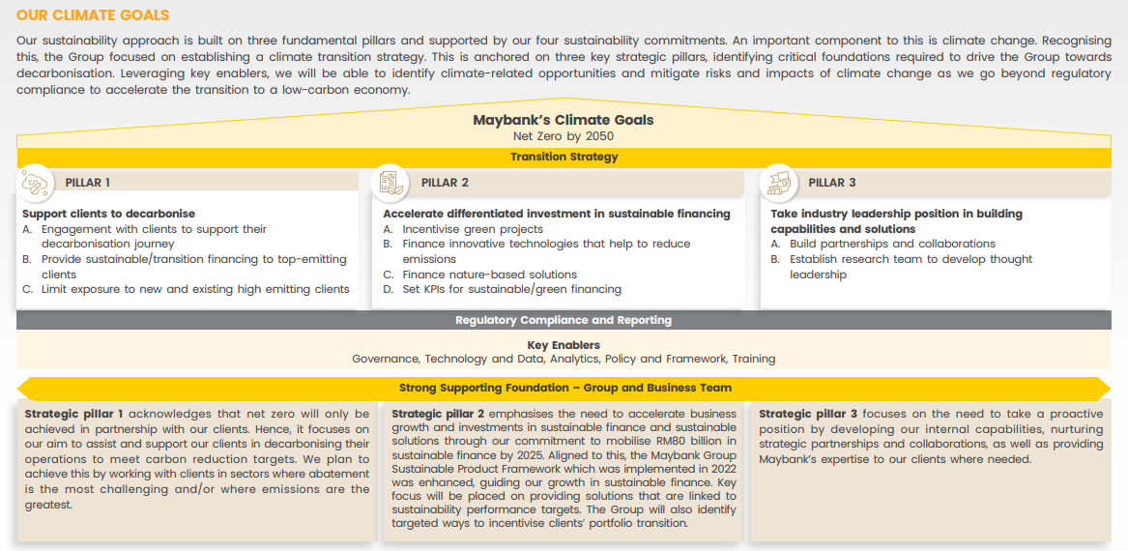

## Identification and Impact of Climate-related Risks

***Physical Risk***

At [Client’s Name] physical risk is defined as the risk directly or indirectly impacting the group’s assets, financials, productivity, and business operations due to extreme weather events and climactic changes. [Client’s Name] has classified physical risk into the following categories, with table xx providing further explanation on the types of

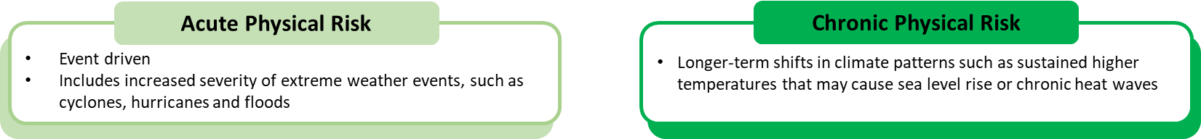

**Table 4. Description of relevant climate-related risks and its potential impact on [Client’s Name]**

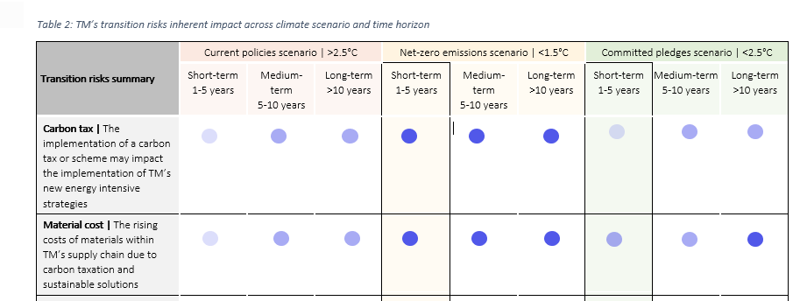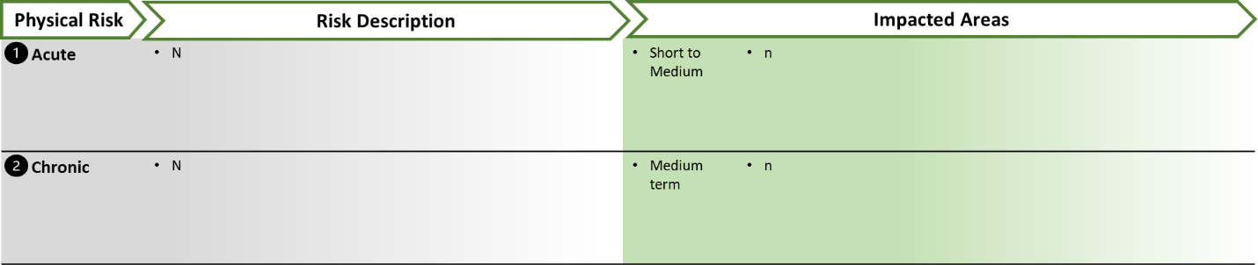

## Climate-related Opportunities

**Table 5. Description of relevant climate-related opportunities and its potential impact on [Client’s Name]**

|  |  |  |  |
| --- | --- | --- | --- |
| **Opportunity** | **Opportunity Description** | **Impacted Areas** | |
| Resource efficiency | Development and expansion of sustainable products. | Short to Medium Term | * Products & services / * Access to capital |
| Products and services | Development and expansion of sustainable products. Focus growth on sustainable strategy and alignment to the goals of the Paris Agreement. | Medium Term | * Products & services |
| Resilience | Development of sophisticated scenario analysis that is integrated into the investment decision making process. | Long Term | * Products & services * Adaptation & mitigation * Activities, Acquisitions or divestments |
| Adaptation | Development of specific adaptation strategies for  capital to be allocated to climate opportunities. | Long Term | * Products & services / * Access to capital |

## Our Transition Plan Towards Net-Zero

[Client’s Name] clarifies in the Environmental Policy our awareness of environmental issues, our specific actions, and our stance on addressing climate change to achieve a decarbonized society, all of which form the basis of our environmental initiatives.

In addition, we have developed “[Client’s Name]'s Approach to Achieving Net Zero by 2050" and "Net Zero Transition Plan" to clarify medium to long-term strategies and initiatives. These documents outline the actions we take to achieve a decarbonized society by 2050 by pursuing efforts to limit the temperature increase within 1.5°C, putting the above policy and stance into practice. Based on these policies and plans, we will actively promote climate-related initiatives and information disclosure in line with international standards.

The Net Zero Transition Plan formulated in 2022 has been revised to promote more integrated responses to climate issues across the Group, from the perspectives of facilitating transition in the real economy, capturing business opportunities, and enhancing risk management. The plan was formulated in reference to the transition plan frameworks from TCFD, GFANZ, and other organizations and was adopted by the Board of Directors of [Client’s Name].

**Figure 6. Overview of [Client’s Name]’s net-zero transition plan**

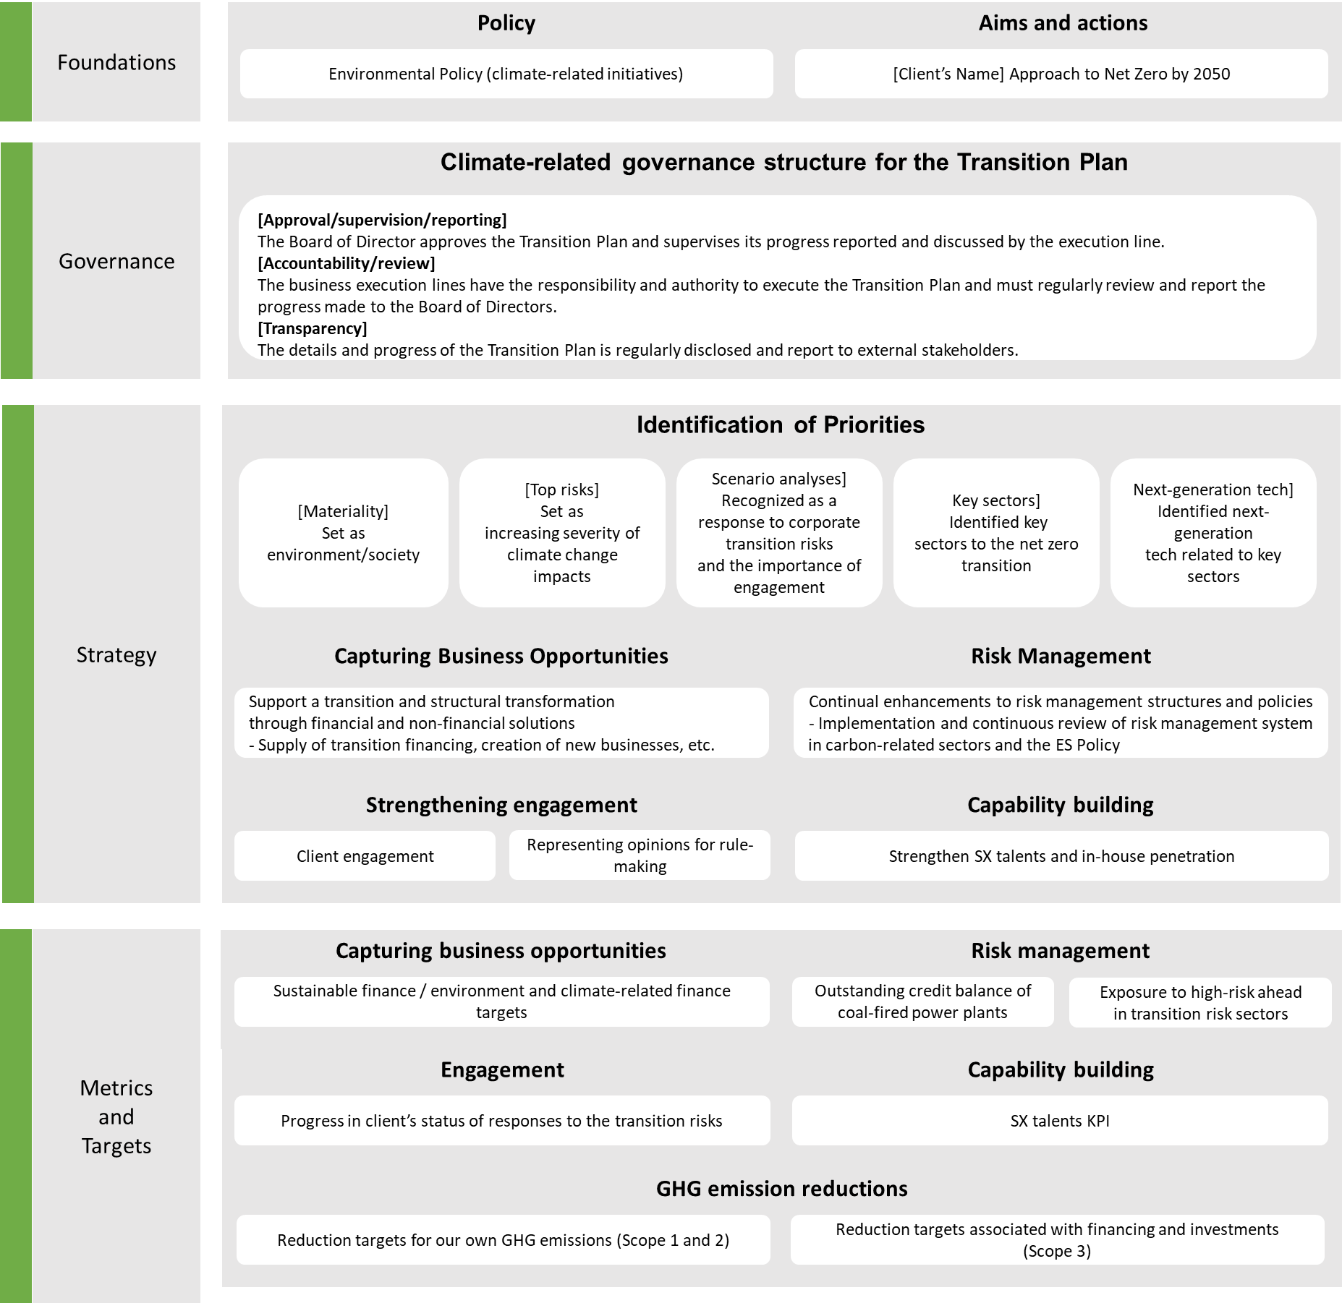

### Integration of Climate-related Risks and Opportunities into the Group’s Strategic Planning Process

To integrate climate-related risks and opportunities into our strategic planning, [Client’s Name] conducts comprehensive climate risk assessments, including scenario analyses and stress tests. These evaluations help us understand the impacts of various climate scenarios on our operations, financial performance, and asset portfolios. This approach enables us to identify and mitigate risks while capitalizing on opportunities from the transition to a low-carbon economy. Climate-related risks, such as extreme weather events and regulatory changes, significantly influence our asset valuations, operational costs, and compliance requirements. On the other hand, opportunities in renewable energy, energy efficiency, and green financial products provide competitive advantages and drive sustainable growth.

These risks and opportunities directly shape our strategic planning, prompting us to adapt business models, diversify portfolios, and innovate product offerings. By understanding high-carbon industry risks, we can reduce exposure, while growth areas in clean energy and sustainable finance align our investments with long-term environmental goals.

We embed climate-related metrics into key performance indicators (KPIs) and use advanced data analytics to monitor sustainability progress. Regular engagement with clients, investors, and regulators ensures our strategies align with climate trends and regulatory requirements. Additionally, we promote continuous learning and cross-functional collaboration through training programs, integrating climate considerations into all aspects of strategic planning. These proactive measures enhance our resilience to climate-related risks and enable us to seize new opportunities, supporting our strategic objectives and global sustainability efforts.

### Sector-specific Strategies to Achieve a Low-carbon Society.

#### 5.2.2.1 Sector Specific Risks and Opportunities

**Figure 7. Evaluation of sector specific risks and opportunities**

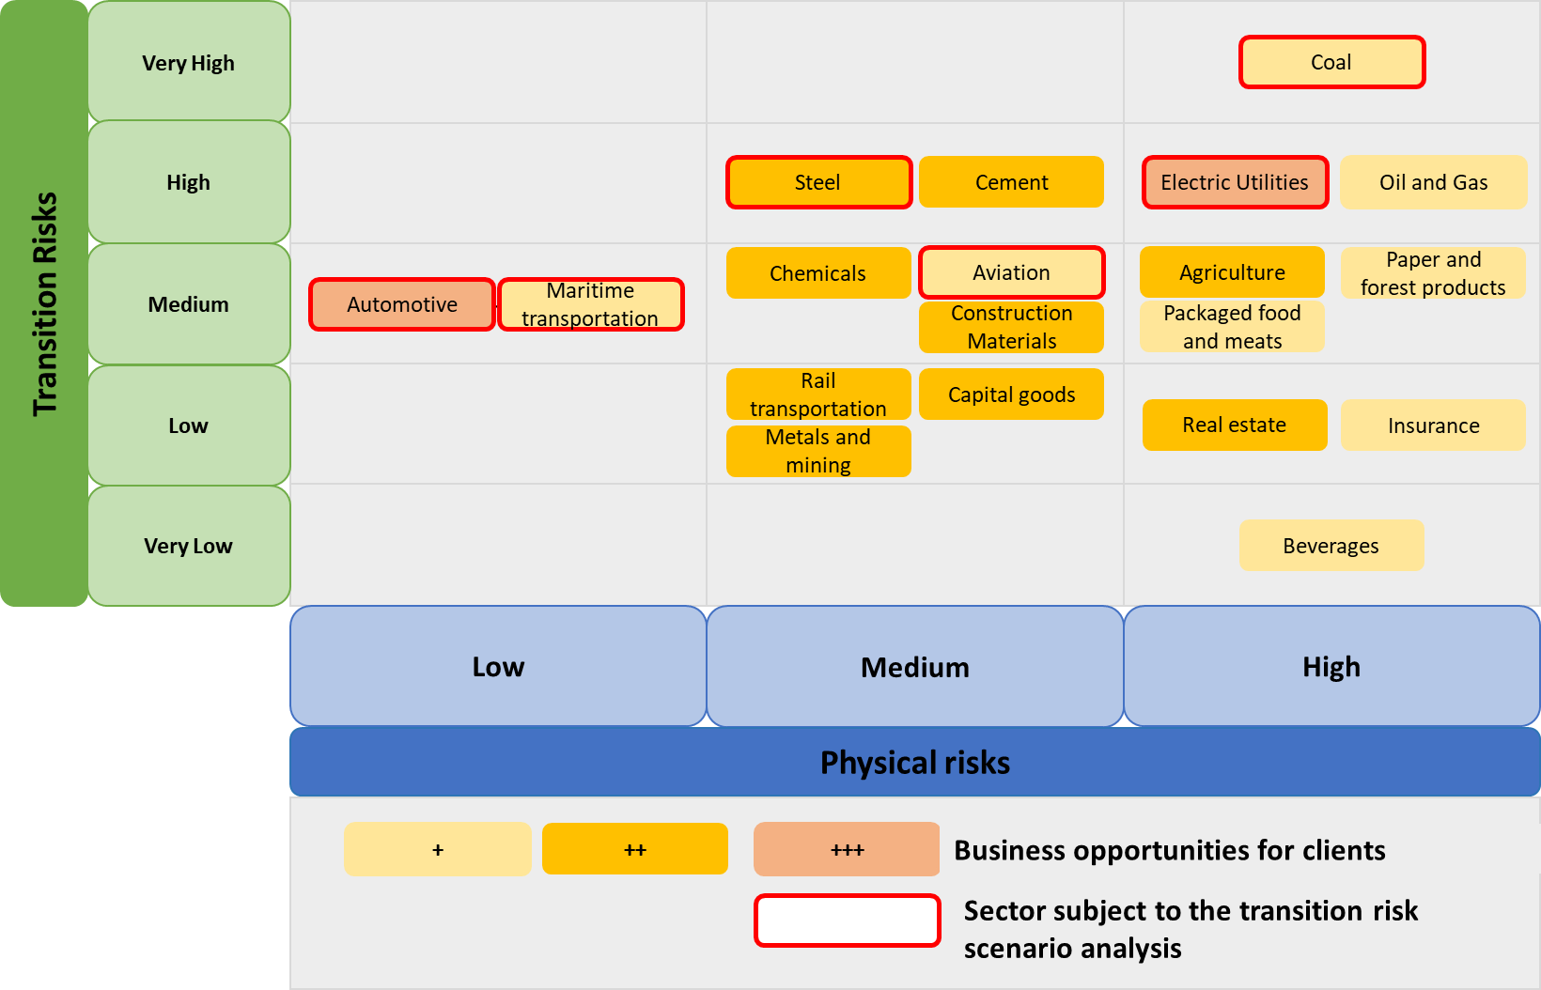

#### 5.2.2.2 Strategies for Decarbonisation

At [Client’s Name], our commitment to sustainability is reflected in our comprehensive decarbonization strategies across key sectors. In the transport sector, we are investing in electric and hybrid vehicle technologies, developing infrastructure for renewable fuels, and encouraging the adoption of public transportation and car-sharing initiatives. For manufacturing, we are implementing energy-efficient processes, transitioning to renewable energy sources, enhancing waste reduction, and recycling practices, and optimizing supply chain operations to lower emissions. In the real estate sector, we are focused on improving building energy efficiency through advanced HVAC systems, implementing green building standards, retrofitting existing buildings with sustainable materials, and utilizing smart building technologies to monitor and reduce energy consumption.

Our energy supply strategies include a strong emphasis on transitioning to renewable energy sources such as wind, solar, and hydropower. We are also investing in advanced energy storage solutions and smart grid technologies to enhance energy efficiency and reliability. In agriculture, we are promoting sustainable farming practices, such as precision agriculture and regenerative farming, to enhance soil health and reduce emissions. We are also working on reducing methane emissions through improved livestock management and promoting the use of organic fertilizers. By integrating these strategies, we aim to significantly reduce our carbon footprint, mitigate climate risks, and drive progress toward a more sustainable future for our planet.

5.2.2.3 Transpor*t*

At [Client’s Name], we are committed to achieving net-zero emissions by [Target Year] with a focused strategy on decarbonizing the transport sector. We will promote electric vehicle (EV) adoption by increasing financing for EV purchases and infrastructure, providing competitive loan terms, and partnering to develop widespread EV charging networks. Additionally, we will support public transportation improvements by funding projects for electric buses and rail systems and collaborating with local governments to enhance accessibility and efficiency.

We will invest in sustainable freight solutions by financing electric and hybrid trucks and encouraging rail and water transport. Furthermore, we will promote alternative mobility options by funding bike-sharing programs, pedestrian infrastructure, car-sharing services, and offering incentives for flexible working arrangements and telecommuting. To foster innovation in low-carbon transport technologies, we will invest in research and development of solutions like autonomous electric vehicles and hydrogen fuel cell vehicles. We will develop green finance products, such as green bonds and loans, tailored to support sustainable transport projects.

By integrating these strategies into our net-zero plans, [Client’s Name] aims to lead in decarbonizing the transport sector. These actions align with our commitment to sustainability and position us as a key player in the transition to a low-carbon economy. We are dedicated to working collaboratively with stakeholders to achieve these ambitious goals and create a sustainable future for all.

**Table 7. Overview of [Client’s Name] decarbonisation plan for the transport sector**

|  |  |
| --- | --- |
| **Time Horizons** | **Strategies to Decarbonise the Transport Sector** |
| **Short-term** |  |
| **Medium-term** |  |
| **Long-term** |  |

#### 5.2.2.4 Energy

At [Client’s Name], we are committed to achieving net-zero emissions by [Target Year]. Our decarbonization strategy focuses on several key areas. We aim to increase solar and wind energy utilization, aligning with the International Energy Agency's (IEA) goal of 40% renewable energy by 2030. We support new clean technologies in heavy industries to achieve a 50% emission reduction by 2030, in line with the Paris Agreement. For new buildings, we ensure zero-carbon readiness by 2030, following the World Green Building Council's recommendations.

We address methane emissions in the oil and gas sector, targeting a 45% reduction by 2025 as per the Global Methane Pledge. We also promote the transition from HFCs to climate-friendly cooling solutions, aiming for a phase-out by 2030 in accordance with the Kigali Amendment. To accelerate renewable energy adoption, we invest in projects to reach 70% renewable electricity by 2040, as projected by the International Renewable Energy Agency (IRENA). Additionally, we support low-carbon fuels, targeting 30% of transportation fuels by 2030, following Bioenergy International's guidelines.

By integrating these strategies into our net-zero plans, [Client’s Name] aims to drive significant progress in decarbonizing the energy sector. These actions align with our commitment to sustainability and position us as a leader in the transition to a low-carbon economy. We are dedicated to working collaboratively with our stakeholders to achieve these ambitious goals and create a sustainable future for all.

**Table 8. Overview of [Client’s Name] decarbonisation plan for the energy sector**

|  |  |
| --- | --- |
| **Time Horizons** | **Strategies to Decarbonise the Energy Sector** |
| **Short-term** |  |
| **Medium-term** |  |
| **Long-term** |  |

*Manufacturing*

At [Bank Name], we are committed to achieving net-zero emissions by [Target Year] through a focused strategy to decarbonize the manufacturing sector. We enhance energy efficiency by financing the adoption of energy-efficient technologies and retrofitting facilities. We promote a circular economy by funding projects that emphasize recycling, reusing materials, and reducing waste. We support the electrification of industrial processes by providing financing for transitioning from fossil fuels to electric alternatives.

We advocate for low-carbon materials by funding research and incentivizing their use. Additionally, we invest in carbon capture and storage (CCS) technologies, partnering with industry leaders to develop and scale these solutions. We promote digitalization and automation in manufacturing through smart technologies like IoT, AI, and robotics to optimize production and reduce emissions. Furthermore, we drive collaboration by establishing industry partnerships focused on sustainability and decarbonization.

By integrating these strategies into our net-zero plans, [Bank Name] aims to lead in decarbonizing the manufacturing sector, aligning with our commitment to sustainability and positioning us as a key player in the transition to a low-carbon economy. We are dedicated to working collaboratively with stakeholders to achieve these goals and create a sustainable future for all.

**Table 9. Overview of [Client’s Name] decarbonisation plan for the manufacturing sector**

|  |  |
| --- | --- |
| **Time Horizons** | **Strategies to Decarbonise the Manufacturing Sector** |
| **Short-term** |  |
| **Medium-term** |  |
| **Long-term** |  |

*Real Estate*

At [Client’s Name], we are committed to achieving net-zero emissions by [Target Year] through a targeted strategy to decarbonize the real estate sector. We finance the development and retrofitting of green buildings by offering favourable loan terms and incentives for projects that meet energy efficiency and sustainability standards. This includes improvements like better insulation, energy-efficient windows, and advanced HVAC systems.

We promote the integration of smart building technologies to optimize energy use. By funding building automation systems, smart meters, and IoT devices, we help property owners reduce energy consumption and costs. Additionally, we support the use of renewable energy sources in real estate projects, financing the installation of solar panels, geothermal systems, and energy storage solutions.

We advocate for sustainable urban planning by funding projects that create walkable communities, enhance public transportation, and incorporate green spaces. Promoting mixed-use developments and reducing urban sprawl supports sustainable living and reduces emissions. Furthermore, we emphasize sustainability assessments and certifications, offering financing for properties seeking green building certifications like LEED or BREEAM.

By integrating these strategies into our net-zero plans, [Bank Name] aims to lead in decarbonizing the real estate sector, aligning with our commitment to sustainability and positioning us as a key player in the transition to a low-carbon economy. We are dedicated to working with stakeholders to achieve these ambitious goals and create a sustainable future for all.

**Table 10. Overview of [Client’s Name] decarbonisation plan for the real estate sector**

|  |  |
| --- | --- |
| **Time Horizons** | **Strategies to Decarbonise the Real Estate Sector** |
| **Short-term** |  |
| **Medium-term** |  |
| **Long-term** |  |

### Alignment with International Climate Commitments and Policies

At [Client’s Name], we are committed to aligning our operations and strategies with international climate commitments and policies. By integrating frameworks such as the Paris Agreement, the UN Sustainable Development Goals (SDGs), and the recommendations of the Task Force on Climate-related Financial Disclosures (TCFD), we aim to support global efforts to mitigate climate change. Our dedication to these standards underscores our commitment to sustainable development, reducing carbon emissions, and promoting environmental stewardship across all aspects of our business.

**Table 11. Overview of [Client’s Name] commitment to international initiatives and plans**

|  |  |  |
| --- | --- | --- |
| **Organisation/Initiative** | **Description** | [Client’s Name] **involvement** |
| Glasgow Financial Alliance for Net Zero | The Glasgow Financial Alliance for Net Zero (GFANZ) mobilizes the financial sector to achieve net-zero emissions by 2050, aligning financial activities with Paris Agreement goals through collaboration, interim targets, and best practice sharing. |  |
| Net-Zero Banking Alliance | The Net-Zero Banking Alliance (NZBA) mobilizes the banking sector to achieve net-zero emissions by 2050. It aligns banks' portfolios with Paris Agreement goals through science-based targets, best practice sharing, and collaboration. |  |
| UN Sustainable development Goals | The UN Sustainable Development Goals (SDGs) guide banks to support sustainable development, driving positive social, environmental, and economic impacts. By aligning with the SDGs, banks contribute to a sustainable future by 2030. |  |
| United Nations Framework Convention on Climate Change (UNFCCC) | A global platform for countries to work together on climate change mitigation and adaptation. The UNFCCC oversees the implementation of the Paris Agreement. |  |
| World Bank | Offers a range of financial products and policy advice to help countries tackle climate change, including supporting the implementation of TCFD recommendations |  |

## Scenario Analysis

### Approach to Conducting Climate-related Scenario Analysis

#### 5.3.1.1 Transition Risks

**Figure 8. [Client’s Name] approach to transition risk scenario analysis**

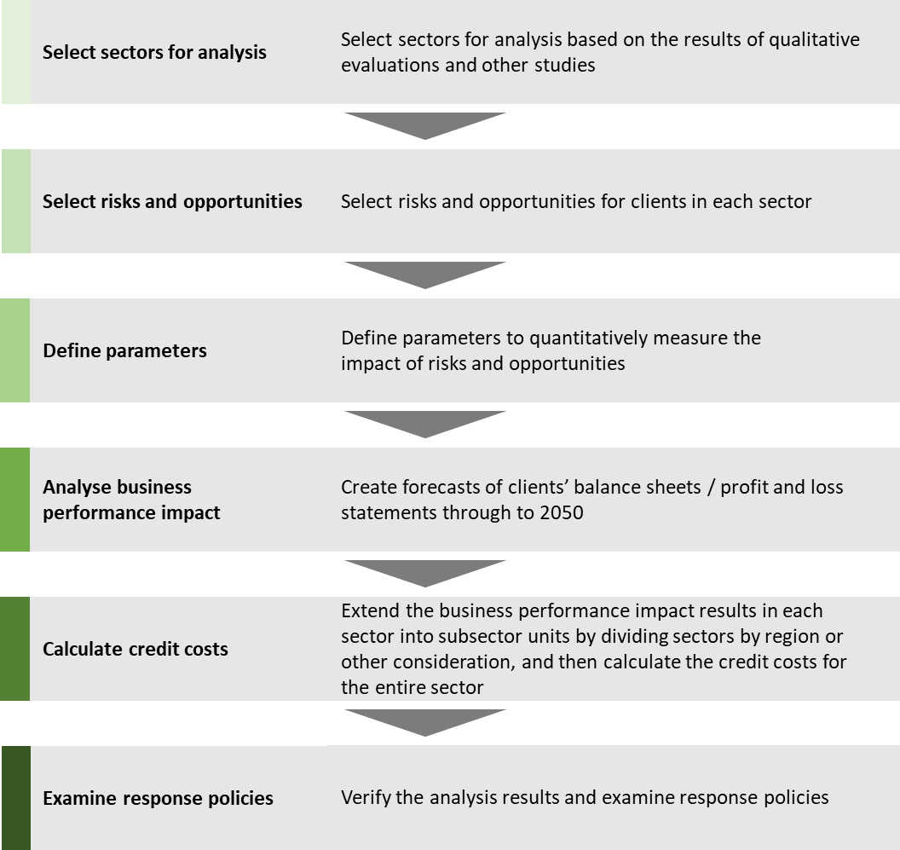

#### 5.3.1.2 Physical Risks

**Figure 9. [Client’s Name] approach to physical risk scenario analysis**

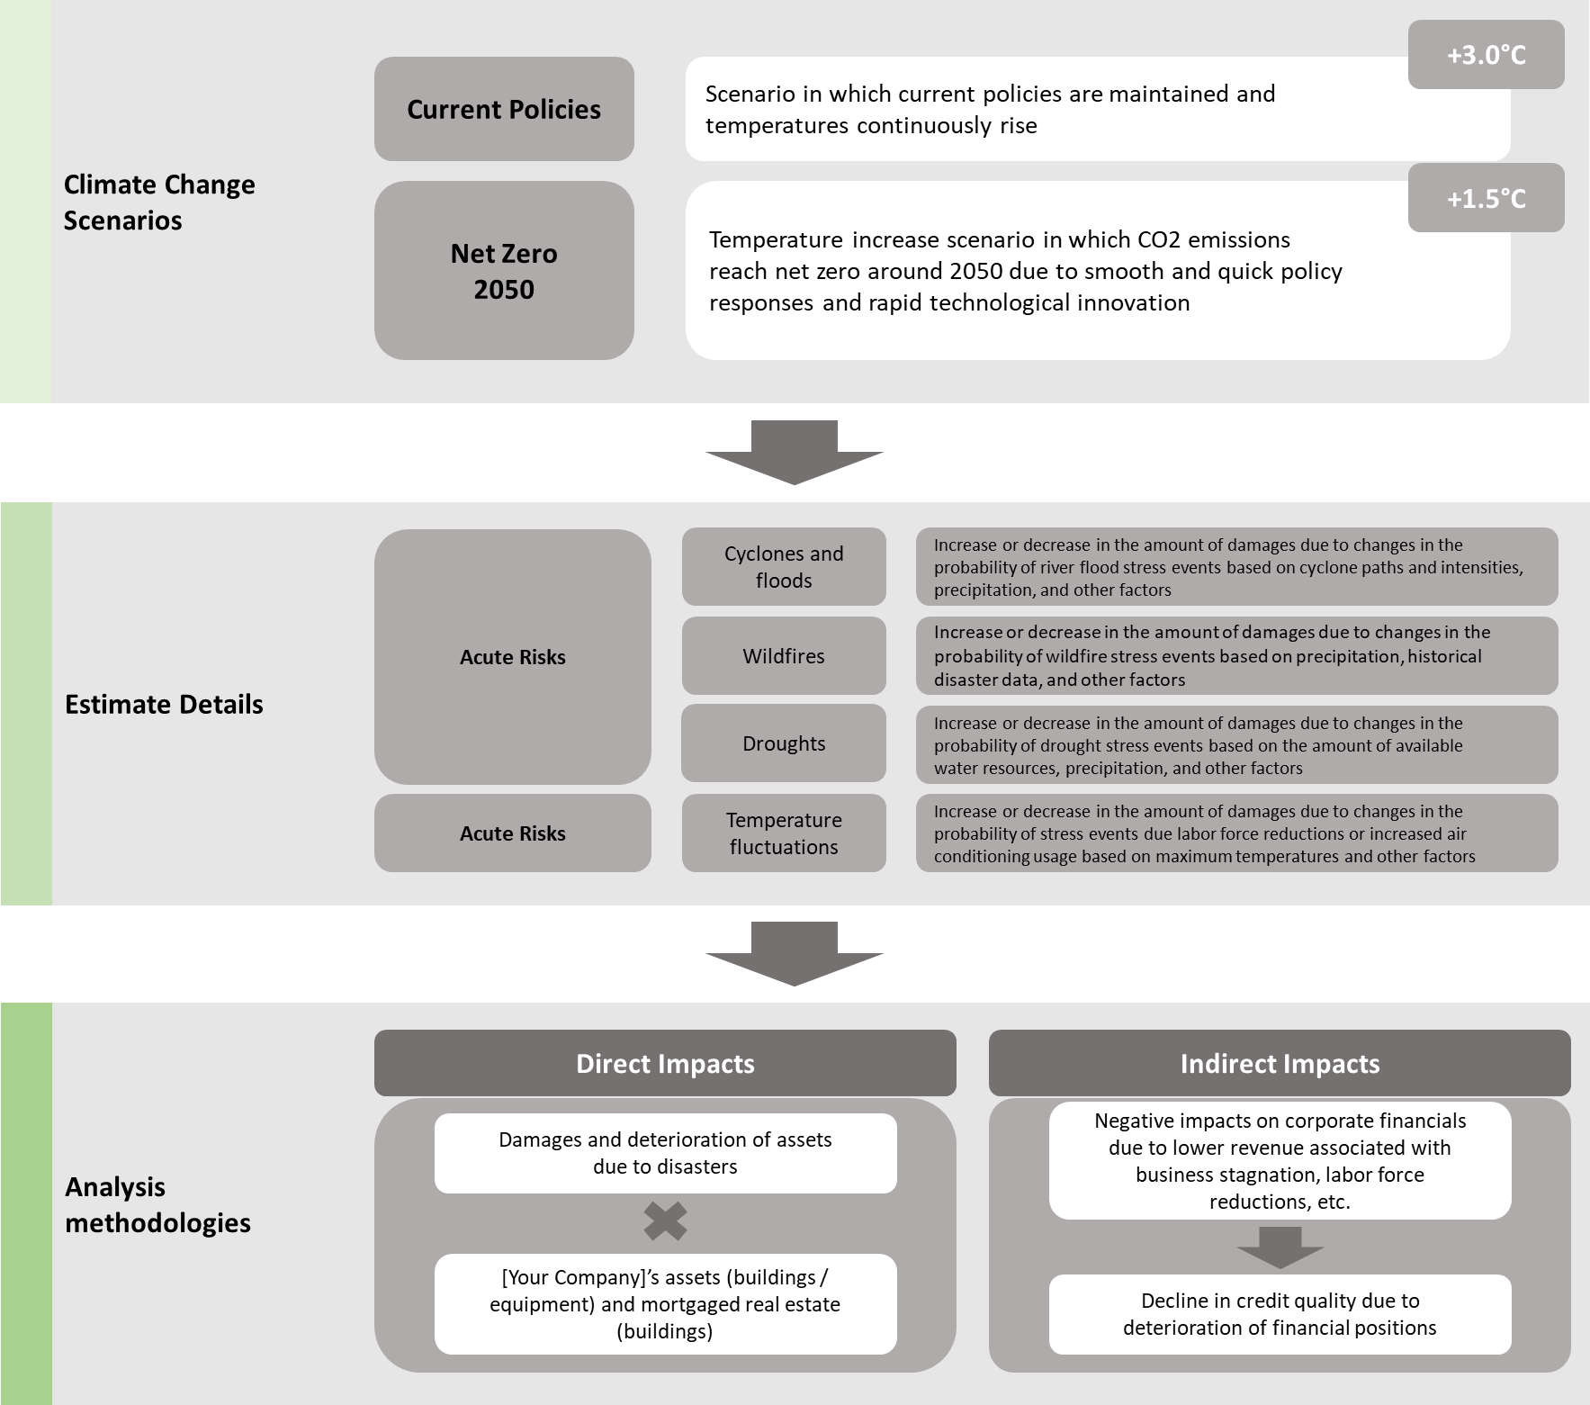

### Overview of Scenarios Used

**NGFS**

At [Client’s Name], we incorporate NGFS (Network for Greening the Financial System) scenarios in our scenario analysis to evaluate the potential financial and operational impacts of climate change. By utilizing NGFS scenarios, we can explore a variety of climate futures based on different policy and technology pathways. This enables us to assess risks and opportunities under various transition and physical risk scenarios. Integrating NGFS scenarios into our strategic planning allows us to make informed decisions, enhance our risk management processes, and ensure our business strategies are resilient and aligned with global climate goals.

**Table 12. Overview of NGFS scenarios**

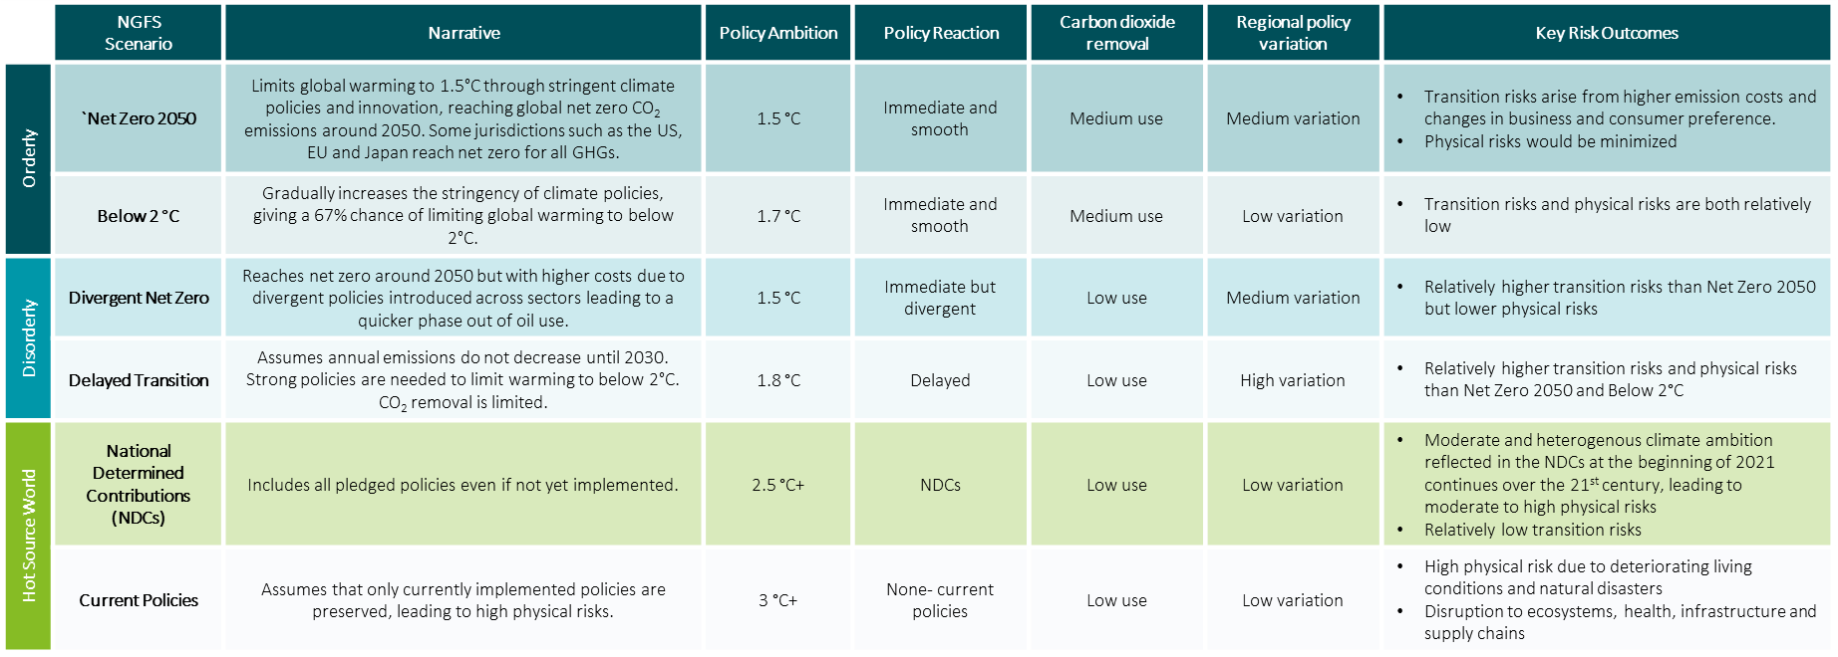

**Representative Concentration Pathways (RCPs) by IPCC**

At [Client’s Name], we utilize Representative Concentration Pathways (RCP) in our scenario analysis to evaluate potential future climate-related impacts on our operations and strategy. By incorporating RCP scenarios, we can assess a range of possible climate futures based on varying levels of greenhouse gas concentrations. This approach allows us to understand and prepare for different climate trajectories, helping us to identify and mitigate risks, and capitalize on opportunities associated with climate change. Using RCP scenarios ensures our strategic planning and risk management are aligned with scientifically grounded projections, thereby enhancing our resilience and sustainability.

**Table 13. Overview of RCP scenarios**

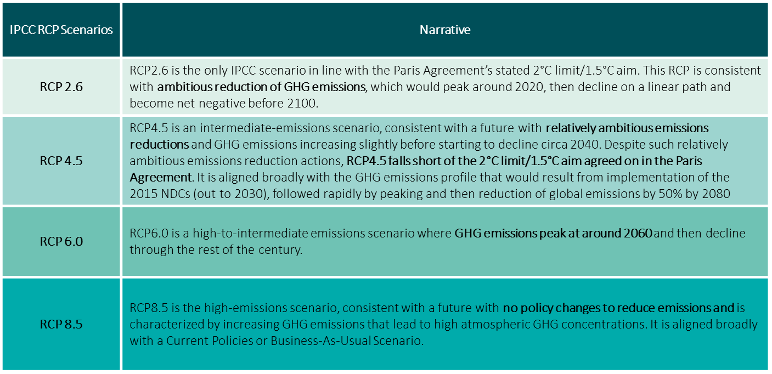

### Strategic Resilience to Climate Change

For our scenario analyses of physical risks, we collaborate with consulting firms and data vendors to enhance the accuracy and comprehensiveness of our assessments. We publish the impacts of climate change, focusing on acute risks like cyclones, floods, wildfires, and droughts, as well as chronic risks such as temperature fluctuations and increased air conditioning usage. This report estimates the maximum impact within a single year if a stress event materializes, using NGFS scenarios for consistency. The analysis now includes overseas companies and large corporations, providing a more comprehensive view of potential impacts. In these scenarios, we estimated additional impacts based on temperature increase pathways in the NGFS scenarios. For acute risks, we analysed river flooding from typhoons, torrential rains, wildfires from dry conditions, and localized water shortages. For chronic risks, we targeted changes in labour forces and air conditioning use due to temperature fluctuations, using damage rates estimated from typhoon path simulations and regression coefficients. Our methodology estimated direct impacts as damages to Group assets and credit costs related to mortgaged real estate. Indirect impacts were estimated as credit costs from client revenue declines due to business stagnation or labour force reductions. The analysis also covered impacts on large corporations with dispersed bases and overseas clients, using damage percentages for major properties and headquarters locations. For our transition risk analyses, we identified critical risks and opportunities related to factors such as demand, prices, and tighter regulations that our clients face in various sectors. We defined the necessary parameters to evaluate these risks and opportunities based on future projection data from NGFS scenarios and publicly available client data. Using these datasets, we analysed the potential increase in [Client’s Name]'s credit costs attributable to transition risks by forecasting the impacts on clients' financial results. Our approach involved a detailed examination of how changes in regulatory landscapes, market demands, and price fluctuations could affect clients' operations and financial stability. We projected these impacts using comprehensive models that incorporate future scenarios and stress tests. This enabled us to assess the potential credit risks associated with our clients' transitions to more sustainable practices or adaptations to regulatory changes. These analyses provide in-depth insights into the methodologies and assumptions used, as well as the specific sectoral impacts projected under different future scenarios. This approach helps [Client’s Name] better understand and manage the financial implications of transition risks on our portfolio, ensuring our strategies are aligned with evolving market and regulatory conditions.

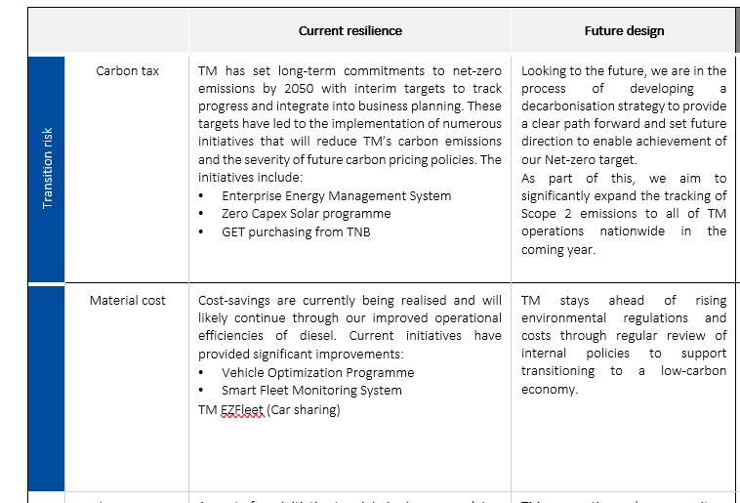

# Risk Management

[Client’s Name], acknowledges that managing climate-related risks is crucial for the continued success of the organisation as it allows us to

## Processes for Managing Climate-related Risks.

[Client’s Name], acknowledges that managing climate-related risks is crucial for the continued success of the organisation as it allows us.

we are committed to proactively managing climate-related risks to ensure the long-term sustainability and resilience of our business. Our approach involves integrating climate risk assessments into our overall risk management framework, which includes identifying, assessing, and mitigating both physical and transition risks. We conduct regular scenario analyses using established frameworks such as the NGFS scenarios to understand potential impacts on our operations, supply chains, and financial performance. Additionally, we engage with stakeholders, including regulators, investors, and customers, to stay informed about emerging climate-related regulations and market expectations. By embedding climate risk considerations into our strategic planning and decision-making processes, we aim to reduce our vulnerability to climate impacts, capitalize on opportunities for innovation and growth, and contribute positively to global climate goals.

**Figure 13. Overview of [Client’s Name] approach to assessing climate-related risks**

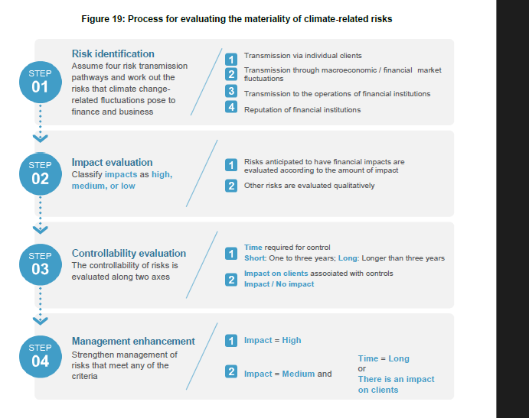

### Integration of Climate-related risks into the Bank’s overall Risk Management Process

At [Client’s Name], we manage climate-related risks through comprehensive risk identification, measurement, and monitoring tools that guide our governance, policies, and processes. Climate considerations are integrated into our Risk Framework and Risk Appetite Statement (RAS), ensuring these risks are embedded in our overall risk management strategy. We have updated our risk management policies to incorporate climate risk considerations where applicable. Climate risks and mitigation activities are regularly reported to senior management and the Board, featuring prominently on the agenda of key committees such as the [MRC], [ERC], and [legal entity Board Risk Committees].

Additionally, we follow a rigorous Environmental and Social Risk Policy Framework to assess and mitigate environmental and social risks across various clients, sectors, and geographies. We have committed to not financing new coal-fired power plants unless they use advanced carbon-reducing technologies, nor new thermal coal mines or expansions of existing ones. As part of our transition strategy, we plan to phase out financing for companies with significant revenue from thermal coal mining by 2025, unless they align with the Paris Agreement goals and diversify away from thermal coal. This commitment has already led to a significant reduction in our exposure to coal-focused companies, with a notable decrease in credit exposure to these sectors.

To further integrate climate risks and opportunities into our risk management process, we conduct scenario analyses and stress testing to understand the potential impacts of different climate scenarios on our operations and financial performance. These analyses help us identify and prepare for potential adverse outcomes, ensuring our strategies are resilient and adaptive. We also engage with stakeholders, including clients, investors, and regulators, to stay informed about emerging climate risks and opportunities and to align our practices with best-in-class standards.

Our company leverages advanced data analytics and technology to monitor environmental indicators and track progress towards sustainability goals. We incorporate climate-related metrics into our performance measurement systems, incentivizing sustainable practices across the organization. Regular training and capacity-building programs for employees at all levels ensure that climate risk management is embedded in our corporate culture.

Through partnerships and collaborations with industry bodies, research institutions, and non-governmental organizations, we stay at the forefront of climate science and policy developments. This enables us to continuously refine our risk management approaches and enhance our ability to seize opportunities arising from the transition to a low-carbon economy. By integrating these comprehensive measures into our decision-making processes, [Company Name] demonstrates a commitment to proactive and effective management of climate-related risks and opportunities, thereby safeguarding our business and contributing to broader environmental sustainability objectives.

Brief Description

### Our Risk Management Framework

At [Client’s Name], we have introduced a Risk Appetite Framework (RAF) to enhance our corporate value by integrating business operations, financial strategies, and risk management. This framework, documented in Risk Appetite Statements (RAS) approved by the Board of Directors, simulates future risks, including those related to carbon sectors and climate change, to estimate medium and long-term impacts. These estimates are reported to the Executive Management Committee, the Board of Directors, and other relevant committees. We have established a comprehensive risk management system to identify, evaluate, and maintain overall risks within acceptable limits. This includes recognizing transition and physical risks from climate change within our framework and controlling risks in line with each risk category and our business strategies. Critical risks are identified to ensure effective risk management aligned with our strategic goals. In instances where climate-related risks may impact credit risk, these are reflected in quantitative evaluations along with other factors. Committed to continuous improvement, [Client’s Name] integrates climate-related risks into our credit risk management. Regular reports on these risk estimates are provided to senior management and the Board, ensuring informed decision-making and alignment with our corporate objectives.

**Figure 10. [Client’s Name] risk management framework**

## Risk Identification

[Client’s Name] conducts comprehensive qualitative evaluations of risks and opportunities by sector to identify climate-related risks, targeting 19 sectors in alignment with the recommended disclosures in the TCFD Recommendations. This thorough approach ensures a detailed understanding of sector-specific vulnerabilities and strengths. Transition risks are evaluated on a five-level scale—Very High, High, Medium, Low, and Very Low—based on criteria such as GHG emissions and carbon efficiencies. These evaluations are crucial for selecting sectors for scenario analyses, ensuring that our strategies are informed by robust data. Additionally, we assess the extent of physical risks and client business opportunities on a three-level scale, enhancing our ability to anticipate and mitigate climate-related impacts. This systematic evaluation process helps raise awareness of climate-related risks across the organization, fostering a proactive risk management culture.

Our organization assumes various risks posed by climate change (climate-related risks) in each risk category, including credit risk, market risk, operational risk, and reputational risk. Recognition of these risks and their management status are regularly reported to the Executive Management Committee, the Board of Directors, and other relevant committees, ensuring high-level oversight and accountability. In [Fiscal Year], we conducted in-depth qualitative evaluations on the materiality of climate-related risks across all risk categories. This integrated approach allowed us to identify significant consequences of climate-related risks, particularly in credit risk (e.g., deterioration in client business performance) and market risk (e.g., decline in the value of stock holdings).

To address these identified risks, we employ both qualitative and quantitative management strategies. High-consequence risks are subject to detailed analysis and targeted response measures, ensuring that we maintain resilience and adaptability in the face of evolving climate challenges. Our commitment to managing climate-related risks is reflected in our continuous improvement of evaluation processes and the integration of climate considerations into our broader risk management framework. By doing so, we strive to safeguard our business operations, support our clients in their transitions, and contribute to broader environmental sustainability goals.

**Figure 11. Overview of Climate-related risks**

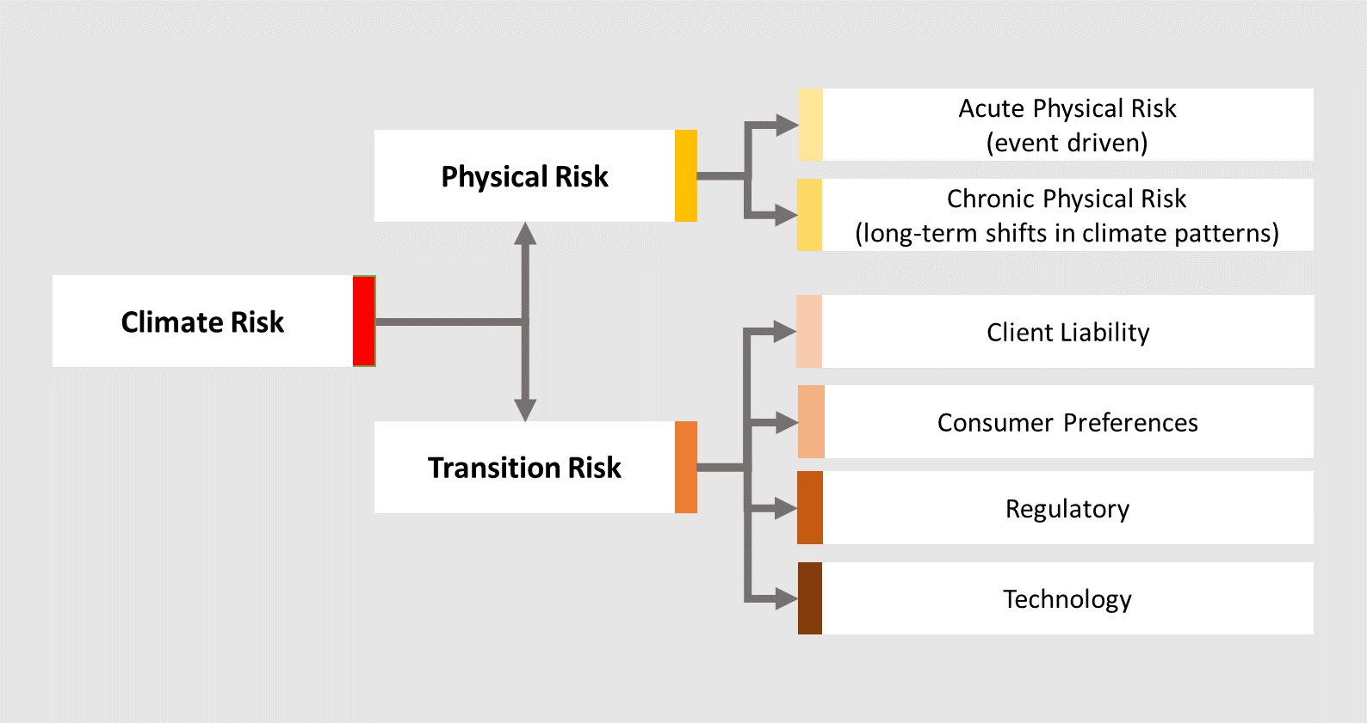

**Table 14. Overview of [Client’s Name] identification process for climate-related risks**

|  |  |
| --- | --- |
| **[Client’s Name] Seven Risk Types** | **[Client’s Company] Climate Risk Identification Processes** |
| **Credit Risk**  The risk of loss arising from the inability or failure of a borrower or counterparty to meet its obligations |  |
| **Market Risk**  The risk that changes in market conditions adversely impact the value of assets or liabilities or otherwise negatively impact earnings. |  |
| **Liquidity Risk**  The inability to meet expected or unexpected cash flow and collateral needs while continuing to support our businesses and customers under a range of economic conditions. |  |
| **Compliance Risk**  The risk of legal or regulatory penalties, financial loss, or reputational damage from non-compliance with laws, regulations, or internal policies. |  |
| **Operational Risk**  The risk of loss resulting from inadequate or failed internal processes or systems, people, or external events. |  |
| **Strategic Risk**  The risk to financial condition from incorrect assumptions, poor business plans, ineffective strategy execution, or failure to adapt to regulatory, economic, or competitive changes. |  |
| **Reputational Risk**: The risk that negative perception of the Company may adversely impact profitability or operations |  |

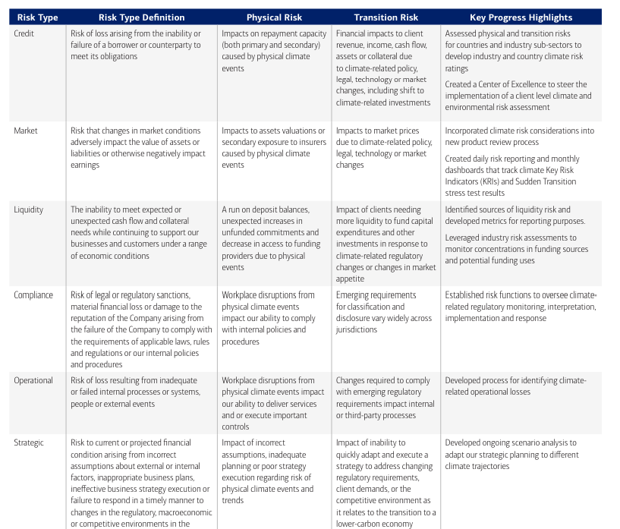

## Risk Management Processes

## Risk Assessment and Measurement

### Processes for Measuring and Assessing Climate-related Risks.

### Methodologies Used to assess “Top and Emerging Risks”.

[Client’s Name] has a top risk management system that designates as top risks those perceived to have a major impact on the Group. This process begins with collecting a broad range of risks that may harm our corporate value, considering changes in internal and external circumstances and our company's specific vulnerabilities and business strategies. Critical risk events are then selected based on evaluations of their transmission pathways, probabilities, and impacts. Finally, the top risks are designated after discussions by executive management, considering the difficulty of controlling these risks. For FY2023, 11 risk events were designated as top risks.

The urgency of addressing climate change has grown stronger globally, and stakeholders increasingly expect and demand more action from financial institutions. In response, we designated the worsening impact of climate change as an existential top risk that the Group must recognize and address.

By recognizing and managing these top risks, [Client’s Name] aims to enhance its resilience and ensure the alignment of risk management practices with our strategic objectives and stakeholder expectations.

**Figure 12. Overview of [Client’s Name] risk prioritisation approach**

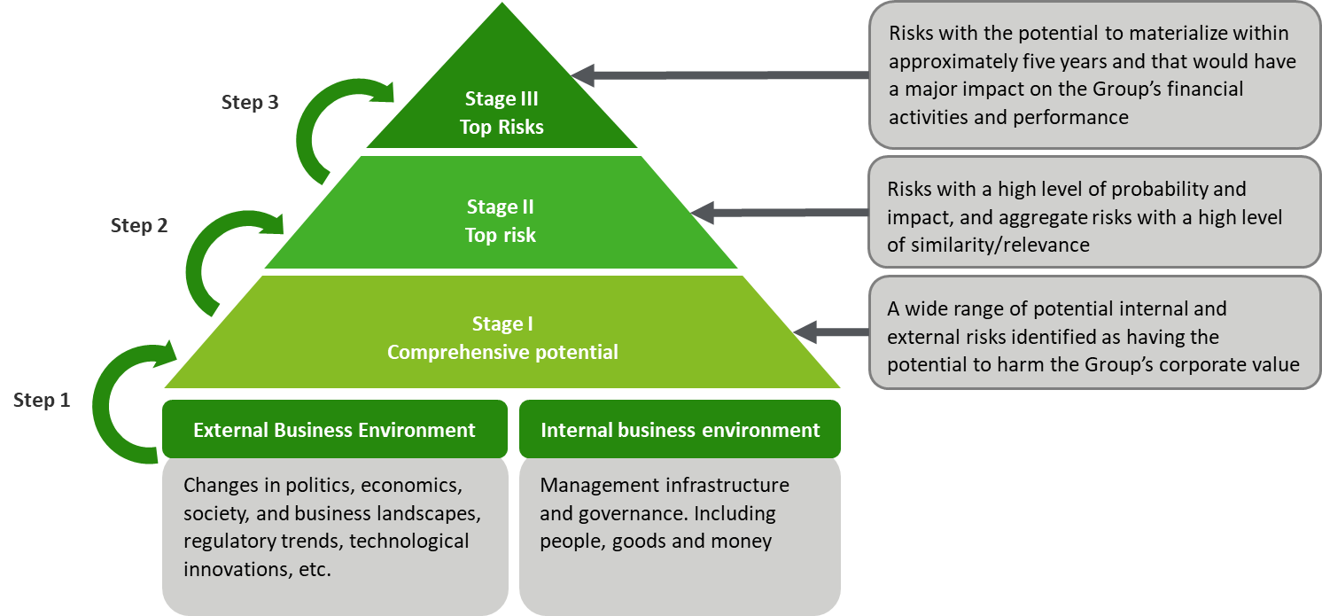

**Table 16. Overview of [Client’s Name] climate-related risk assessment processes**

|  |  |
| --- | --- |
| **[Client’s Name] Seven Risk Types** | **[Client’s Name] Climate Risk Assessment Processes** |
| **Credit Risk** |  |
| **Market Risk** |  |
| **Liquidity Risk** |  |
| **Compliance Risk** |  |
| **Operational Risk** |  |
| **Strategic Risk** |  |
| **Reputational Risk**: |  |

### Transmission Channels for Climate-related risks

**Figure 13. Overview of transmission channels for physical and transition risks**

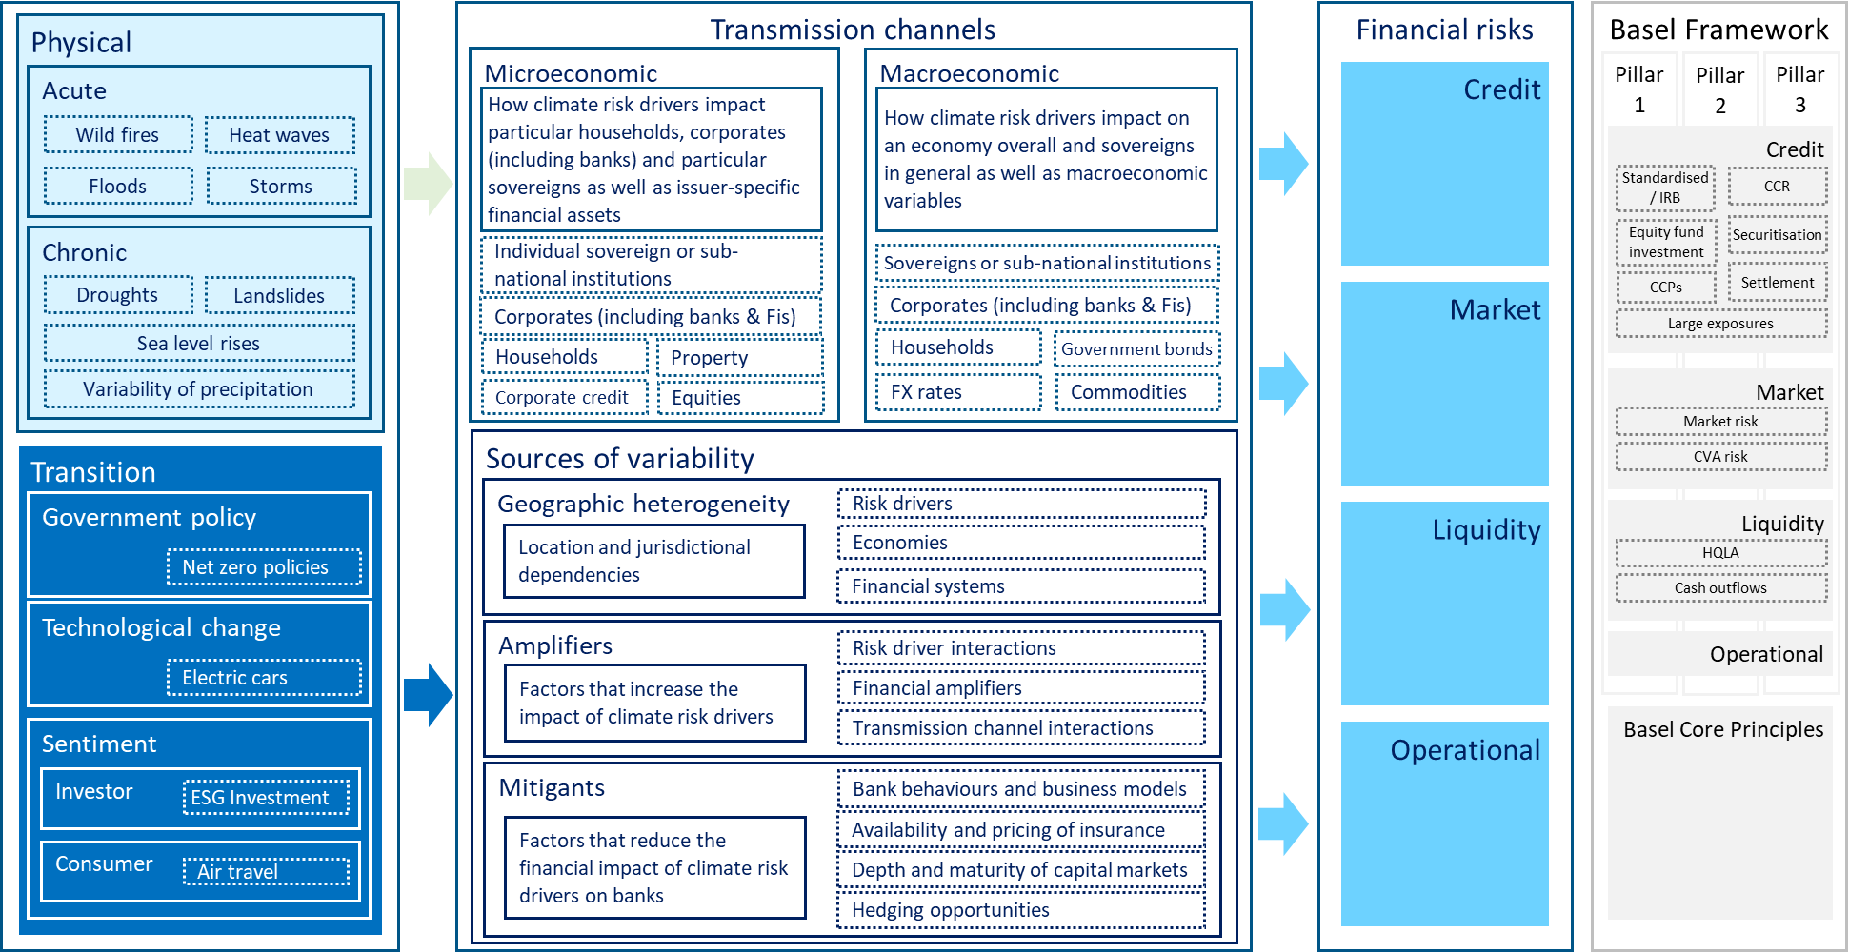

***Risk monitoring***

***Risk control***

# Metrics and Targets

## An Overview of Metrics

### Key Metrics used to Assess Climate-related Risks and Opportunities

By integrating TCFD's recommended metrics into our reporting framework, we aim to provide stakeholders with a comprehensive view of our climate-related risks, opportunities, and performance. These metrics enable us to systematically measure and disclose our greenhouse gas emissions, energy usage, and climate impact across our operations and value chain. Furthermore, they support our efforts in setting science-based targets and tracking progress towards our sustainability goals. By aligning with TCFD's globally recognized framework, we ensure our disclosures meet the evolving expectations of investors, regulators, and other key stakeholders, thereby reinforcing our commitment to sustainable business practices and climate resilience.

**Table 17. Overview of Metrics and Targets**

|  |  |  |  |
| --- | --- | --- | --- |
| **Metric Category** | **Example Unit** | **[Client’s Name]’s utilisation of metric** | **Relevant Industry usage** |
| **GHG emissions**  Absolute Scope 1, Scope 2. and Scope 3 (if appropriate) | MT of CO2e |  | * Manufacturing * Energy * Transportation * Agriculture * Retail |
| **Transition Risks**  Amount and extent of assets or business activities vulnerable to transition risks | Amount or percentage |  | * Energy * Automotive * Financial Services * Real Estate * Heavy Industry |
| **Physical Risks**  Amount and extent of assets or business activities vulnerable to physical risks* | Amount or percentage |  | * Insurance * Agriculture * Real Estate * Tourism * Infrastructure |
| **Climate-Related Opportunities**  Proportion of revenue, assets, or other business activities aligned with climate-related opportunities | Amount or percentage |  | * Renewable Energy * Technology * Financial Services * Real Estate * Consumer Goods |
| **Capital Deployment**  Amount of capital expenditure, financing, or investment deployed toward climate-related risks and opportunities | Reporting currency |  | * Financial Services * Energy * Technology * Real Estate * Manufacturing |
| **Internal Carbon Prices**  Price on each ton of GHG emissions used internally by an organization | Price in reporting currency, MT of CO2e |  | * Energy * Manufacturing * Utilities * Transportation * Retail |
| **Remuneration**  Proportion of executive management remuneration linked to climate considerations** | Percentage, weighting, description, or amount in reporting currency |  | * Financial Services * Technology * Healthcare * Energy * Consumer Goods |

### Detailed Reporting of Greenhouse Gas Emissions

#### 7.1.2.1 Scope 1 and 2

**Table 18. Overview of [Client’s Name] Scope 1 and Scope 2 greenhouse gas (GHG) emissions**

|  |  |  |  |  |  |
| --- | --- | --- | --- | --- | --- |
| ***Greenhouse Gas (GHG) Emissions*** | ***Units*** | ***20__***  ***(Baseline Year)*** | ***20__*** | ***20__*** | ***20__*** |
| **Scope 1 and Location-Based Scope 2 Emissions** | | | | | |
| Scope 1 Direct Emissions | Metric ton tCO2e |  |  |  |  |
| Location-Based Indirect Scope 2 Emissions | Metric ton CO2e |  |  |  |  |
| Total Scope 1 and Location-Based Scope 2 Emissions | Metric ton CO2e |  |  |  |  |
| Reduction in Total Scope 1 and Location-Based- Scope 2 Emissions | % decrease from base year |  |  |  |  |
| **Scope 1 and Market-Based Scope 2 Emissions** | | | | | |
| Scope 1 Direct Emissions | Metric ton CO2e |  |  |  |  |
| Market-Based Scope 2 Indirect Emissions | Metric ton CO2e |  |  |  |  |
| Total Gross Scope 1 and Market-Based Scope 2 Emissions | Metric ton CO2e |  |  |  |  |
| Total Net Scope 1 and Market-Based Scope 2 Emissions | Metric ton CO2e |  |  |  |  |
| Reductions in Total Net Scope 1 and Market-Based Scope 2 Emissions | % decrease from base year |  |  |  |  |

#### 7.1.2.2 Scope 3

**Table 18. Overview of [Client’s Name] Scope 3 greenhouse gas (GHG) emissions**

|  |  |  |  |  |  |
| --- | --- | --- | --- | --- | --- |
| ***Greenhouse Gas (GHG) Emissions*** | ***Units*** | ***20__***  ***(Baseline Year)*** | ***20__*** | ***20__*** | ***20__*** |
| **Scope 3** | | | | | |
| Category 1 – Purchased Goods | Metric ton tCO2e |  |  |  |  |
| Category 2 – Capital Goods | Metric ton CO2e |  |  |  |  |
| Category 3 – Fuel and Energy-related Activities | Metric ton CO2e |  |  |  |  |
| Category 4 – Upstream Transportation and Distribution | % decrease from base year |  |  |  |  |
| Category 5 – Waste | Metric ton CO2e |  |  |  |  |
| Category 6 – Business Travel | Metric ton CO2e |  |  |  |  |
| Category 7 – Employee Commuting | Metric ton CO2e |  |  |  |  |
| Category 8 – Upstream Leased Assets | Metric ton CO2e |  |  |  |  |
| Category 7 – Employee | Metric ton CO2e |  |  |  |  |
| Category 10 – Processing of Sold Products | Metric ton CO2e |  |  |  |  |
| Category 11 – Use of Sold Products | Metric ton CO2e |  |  |  |  |
| Category 12 – End of Life Treatment of Sold Products | Metric ton CO2e |  |  |  |  |
| Category 13 – Downstream Leased Assets | Metric ton CO2e |  |  |  |  |
| Category 14 – Franchises | Metric ton CO2e |  |  |  |  |
| Category 15 – Investments | Metric ton CO2e |  |  |  |  |

**Figure 14. Breakdown of [Client’s Name] Scope 3 emission by category**

**Figure 15. Breakdown of [Client’s Name] annual GHG emissions**

### Additional Relevant Metrics

#### 7.1.3.1 Energy

As part of our commitment to transparency and environmental sustainability, [Client’s Name] closely monitors and reports our energy consumption as a key metric in our climate-related disclosures. In FY[Year], our total energy consumption amounted to [X] MWh, encompassing electricity, heating, and cooling across all our operations. We have implemented various energy efficiency initiatives, such as upgrading to energy-efficient lighting, optimizing HVAC systems, and enhancing data *centre* operations, which have collectively contributed to a [Y]% reduction in energy use compared to the previous year.

Furthermore, we are significantly investing in renewable energy sources to power our facilities, with [Z]% of our total energy consumption now derived from these sustainable sources. This shift is integral to our comprehensive strategy to reduce our carbon footprint and support global efforts to combat climate change. Our energy management practices are meticulously aligned with the goals outlined in our Net-zero strategy and ensure that all disclosures adhere to the TCFD framework.

By continuously tracking and improving our energy consumption metrics, [Client’s Name] aims to enhance operational efficiency, reduce greenhouse gas emissions, and contribute to a sustainable future. We remain dedicated to transparent reporting and ongoing efforts to minimize our environmental impact, reinforcing our commitment to sustainability and responsible business practices.

**Figure 16. [Client’s Name] annual energy consumption across all operations**

#### 7.1.3.2 Capital Deployment

As part of our commitment to sustainable finance, [Client’s Name] meticulously tracks and reports our capital deployment towards climate-related initiatives. In FY[Year], we allocated [X] billion USD to projects and investments that support the transition to a low-carbon economy. This includes financing for renewable energy projects, energy efficiency improvements, sustainable agriculture, and green infrastructure developments. Our strategic capital deployment not only mitigates climate risks but also positions us to capitalize on emerging opportunities in the green economy.

We have established rigorous criteria for selecting and funding projects, ensuring that each investment aligns with our sustainability goals and the broader objectives of the Paris Agreement. Our portfolio includes a diverse range of initiatives, from large-scale wind and solar farms to innovative green technologies and sustainable real estate developments. By prioritizing these investments, we are actively contributing to the reduction of global greenhouse gas emissions and promoting resilience against climate impacts.

Our capital deployment strategy is fully integrated with the TCFD framework, ensuring transparency and accountability in our reporting. We engage regularly with stakeholders, including clients, investors, and regulatory bodies, to align our financial activities with best practices in climate risk management and sustainable development. Through these efforts, [Client’s Name] demonstrates its unwavering commitment to fostering a sustainable future while driving long-term value for our stakeholders.

**Figure 17. Amount invested by [Client’s Name] into its green financing initiatives.**

#### 7.1.3.3 Physical Risks

At [Client’s Name], we assess and report the impact of physical risks associated with climate change on our operations and assets. In FY[Year], we identified [X] million USD in potential losses due to extreme weather events such as floods, hurricanes, and heatwaves. These assessments encompass evaluating the vulnerability of our physical infrastructure, the resilience of our supply chains, and the exposure of our loan portfolios to climate-related events.

Our risk management framework integrates climate data and predictive modelling to identify high-risk areas and quantify potential impacts. This enables us to implement targeted mitigation strategies, such as reinforcing infrastructure, diversifying supply chains, and adjusting loan criteria to account for climate risks. We also conduct regular stress tests and scenario analyses to anticipate the financial impacts of severe weather events and incorporate these findings into our strategic planning.

By systematically tracking and addressing physical risks, we enhance our resilience to climate change and ensure the continuity of our operations. Our proactive approach demonstrates our commitment to transparency, accountability, and sustainable business practices. Through these efforts, [Client’s Name] not only safeguards its assets but also supports the broader objective of building a climate-resilient economy.

## Progress against Committed Targets

|  |  |  |  |  |
| --- | --- | --- | --- | --- |
| **Transition Plan Item** | **Monitored Metrics** | **Targets** | **Recent Results** | **Page Reference** |
|  |  |  |  |  |
|  |  |  |  |  |
|  |  |  |  |  |
|  |  |  |  |  |
|  |  |  |  |  |
|  |  |  |  |  |
|  |  |  |  |  |

# Conclusion and Looking Ahead

Addressing climate change and achieving net zero by 2050 will be a long journey. Each fiscal year, [Client’s Name] examines our progress from the previous fiscal year, the external business landscape, and other factors. We review our action plans based on these examinations and set a course to steadily advance our climate-related initiatives. Our FY[Year] action plans are shown below. We will continue to strengthen and accelerate our responses to climate change across the whole Group to contribute to the achievement of a decarbonized society and to pursue higher corporate value for both [Client’s Name] and our clients.

|  |  |
| --- | --- |
| **Governance** |  |
| **Strategy** |  |
| **Risk Management** |  |
| **Metrics and Targets** |  |

# Appendix

## Appendix 1:

## Appendix 2: